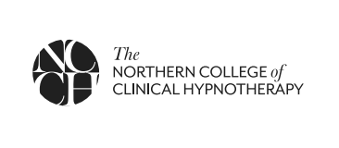

Evaluation Form

Questions

What is your overall assessment of the event? (1 = insufficient - 5 = excellent) 1 2 3 4 5

- Which topics or aspects of the workshop did you find most interesting or useful?

•
•
•
•

- Did the training achieve the programme objectives?

Yes No

If no, why?

Knowledge and information gained from participation at this event?

Met your expectations Yes No Somehow

Will be useful/applicable in my work Definitely Mostly Somehow Not at all

How do you think the workshop could have been made more effective?

- Please comment on the organization of the event (from 1 = insufficient to 5= excellent) 1 2 3 4 5
- Comments and suggestions (including activities or initiatives you think would be useful, for the future)

Further comments or suggestions

THANK YOU!

