Equal Opportunities Learner’s Charter

“Everyone has a part to play in ensuring we achieve equality of opportunity. We believe

that a positive attitude towards equality and diversity is right for our people, our clients and our business suppliers. This means that we must encourage all our people to welcome diversity and respect each person’s individuality”.

Amanda Joy Harrison Director of Studies

The following Learner Charter has been drawn up stating the standards of service you can expect to receive as a learner of The NCCH.

Using the The NCCH you can expect…

- to receive a highly quality learning experience
- to be given equal opportunities and treated fairly
- to be treated with courtesy
- to have access to advice, guidance and support to ensure your choices are informed ones and that your learning needs are met
- to learn in a healthy and safe environment
- to be provided with timely and appropriate information on your progress
- to have staff listen to any issues, suggestions or concerns you may have, and to respond in a relevant manner

In turn as a customer of The NCCH we would like you to:

- be fully committed to your course
- treat our staff with courtesy
- provide us with appropriate information to help us meet your learning and assessment needs
- ensure that your behaviour contributes to a healthy and safe environment
- abide by any rules specifically relating to online assessment
- communicate issues, suggestions or concerns using the procedures outlined in your Student Handbook.

If for any reason you wish to make a formal complaint, then please access our formal complaints procedure on the website or email info@thenortherncollegeofclinicalhypnotherapy.co.uk This policy has been approved & authorised by:

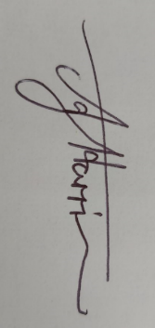
Name: Amanda Joy Harrison
Position: Director of Studies
Date: 3/7/2021
Signature: A.J.Harrison
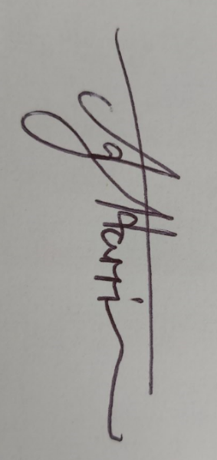
Review of Policy: 7/2022

